

Mark Scheme (Final)

Summer 2007

Edexcel Limited. Registered in England and Wales No. 4496750
Registered Office: One90 High Holborn, London WC1V 7BH


GCE



GCE Mathematics (6683/01)

June 2007

6683 Statistics S1

Mark Scheme

Question Number  1. (a) 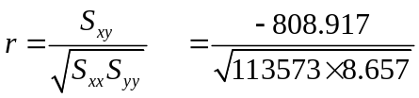 M1  A1  (2)  (b) Houses are cheaper further away from the station or equivalent statement B1  (1)  (c) -0.816 B1∫  (1)  Total 4 marks  Notes:  1(a) M1 for knowing formula and clear attempt to sub in correct values from question.  Root required for method.  Anything that rounds to -0.82 for A1.  Correct answer with no working award 2/2  (b) Context based on negative correlation only required.  Accept Houses are more expensive closer to the station or equivalent statement.  Require ‘house prices’ or ‘station’ and a clear correct comparison.  (c) Accept anything that rounds to -0.82 or ‘the same’ or ‘unchanged’ or equivalent.  Award B1 if value quoted same as answer to (a). | Scheme | Marks

Question Number | Scheme | Marks
2(a)  B1
(1)
(b) 54 B1
(1)
(c) + is an ‘outlier’ or ‘extreme value’ B1
Any heavy musical instrument or a statement that the instrument is heavy B1
(2)
(d) 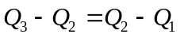 B1
so symmetrical or no skew Dependent – only award if B1 above
B1
(2)
(e) 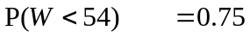(or 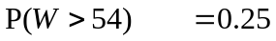)or correctly labelled and shaded diagram M1
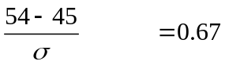 M1B1
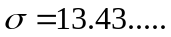 A1
(4)

Total 10 marks

Notes
2(a) Accept 50% or half or 0.5.
Units not required.

(b) Correct answer only.
Units not required.

(c) ‘Anomaly’ only award B0
Accept ‘85kg was heaviest instrument on the trip’ or equivalent for second B1.
Examples of common acceptable instruments; double bass, cello, harp, piano, drums, tuba
Examples of common unacceptable instruments: violin, viola, trombone, trumpet, french horn, guitar

(d) ‘Quartiles equidistant from median’ or equivalent award B1 then symmetrical or no skew for B1
Alternative:
‘Positive tail is longer than negative tail’ or ‘median closer to lowest value’ or equivalent
so slight positive skew.
B0 for ‘evenly’ etc. instead of ‘symmetrical’
B0 for ‘normal’ only

(e) Please note that B mark appears first on ePEN
First line might be missing so first M1 can be implied by second.
Second M1 for standardising with sigma and equating to z value
NB Using 0.7734 should not be awarded second M1
Anything which rounds to 0.67 for B1.
Accept 0.675 if to 3sf obtained by interpolation
Anything that rounds to 13.3 – 13.4 for A1.
3(a) Use overlay B2
(2)
(b) 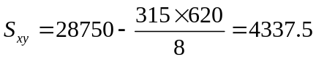 **answer given** so award for method M1
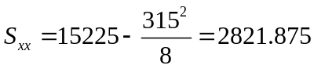 M1A1
(3)
(c) 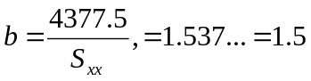 M1,A1
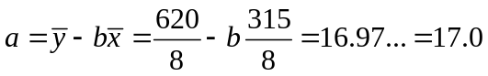 M1,A1
(4)
(d) Use overlay B1∫ B1
(2)
(e) Brand D, B1
since a long way above / from the line dependent upon ‘Brand D’ above B1
Using line: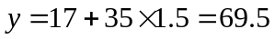 M1A1
(4)
Total 15 marks

Notes:

3(a) Points B2,within 1 small square of correct point, subtract 1 mark each error minimum 0.

(b) Anything that rounds to 2820 for A1

(c) Anything that rounds to 1.5 and 17.0 (accept 17)

(d) Follow through for the intercept for first B1..
Correct slope of straight line for second B1.

(e) Anything that rounds to 69p-71p for final A1.
Reading from graph is acceptable for M1A1.
If value read from graph at 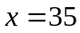is answer given but out of range, then award M1A0.

4(a) B1  M1  A1  (3)  (b)  Venn M1  0.15, 0.35 A1∫ 0.4 and box B1  (3)  (c) 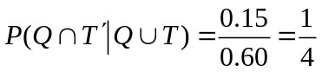 or 0.25 or 25% M1A1∫A1  (3)  Total 9 marks  Notes:  4(a) B1 for 0.6  M1 for use of  - Correct answer only for A1  Alternative:  (25+45+40=)110% B1  110-100=10% M1A1  0.1 stated clearly as the final answer with no working gets 3/3  (b) Two intersecting closed curves for M1, no box required.  At least one label (Q or T) required for first A1.  Follow through (0.25-‘their 0.1’) and (0.45-‘their 0.1’) for A1.  0.4 and box required, correct answer only for B1  Using %, whole numbers in Venn diagram without % sign, whole numbers in correct ratio all OK  (c) Require fraction with denominator 0.6 or their equivalent from Venn diagram for M1  Follow through their values in fraction for A1  Final A1 is correct answer only.  No working no marks. |   0.15 0.1 0.35  0.4
5(a) 18-25 group, area=7x5=35 B1
25-40 group, area=15x1=15 B1
(2)

(b) (25-20)x5+(40-25)x1=40 M1A1
(2)

(c) Mid points are 7.5, 12, 16, 21.5, 32.5 M1
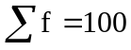 B1
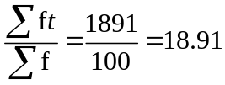 M1A1
(4)
(d) 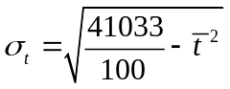 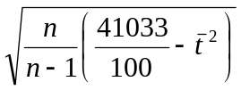 alternative OK M1
M1
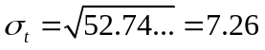 A1
(3)
(e) 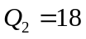 or 18.1 if (n+1) used B1
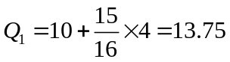 or 15.25 numerator gives 13.8125 M1A1
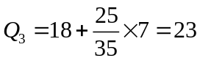 or 25.75 numerator gives 23.15 A1
(4)
(f) 0.376… B1
Positive skew B1∫
(2)
Total 17 marks

Notes:
5(b) 5x5 is enough evidence of method for M1.
Condone 19.5, 20.5 instead of 20 etc.
Award 2 if 40 seen.
(c) Look for working for this question in part (d) too.
Use of some mid-points, at least 3 correct for M1. These may be tabulated in (d).
Their 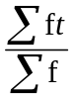 for M1 and anything that rounds to 18.9 for A1.
(d) Clear attempt at 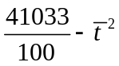 or 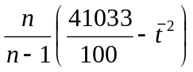 alternative for first M1.
They may use their and gain the method mark.
Square root of above for second M1
Anything that rounds to 7.3 for A1.
(e) Clear attempt at either quartile for M1
These will take the form ‘their lower limit’+ correct fraction x ‘their class width’.
Anything that rounds to 13.8 for lower quartile.
23 or anything that rounds to 23.2 dependent upon method used.
(f) Anything that rounds to 0.38 for B1 or 0.33 for B1 if (n+1) used.
Correct answer or correct statement that follows from their value for B1.
6(a) 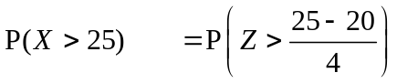 M1
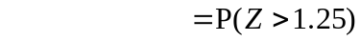 M1
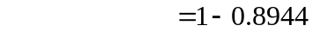
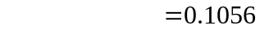 A1
(3)
(b) 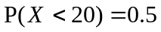so B1
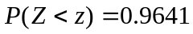, 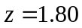 B1
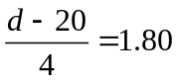 M1
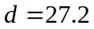 A1
(4)
Total 7 marks

Notes:

(a) Standardise with 20 and 4 for M1, allow numerator 20-25
1- probability for second M1
Anything that rounds to 0.106 for A1.
Correct answer with no working award 3/3

(b) 0.9641 seen or implied by 1.80 for B1
1.80 seen for B1
Standardise with 20 and 4 and equate to z value for M1
Z=0.8315 is M0
Anything that rounds to 27.2 for final A1.
Correct answer with no working 4/4
7(a) 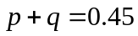 . B1
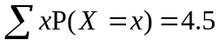 M1
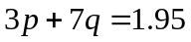 A1
(3)
(b) Attempt to solve equations in (a) M1
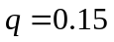 A1
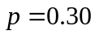 A1
(3)
(c) 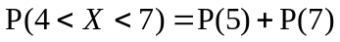 M1
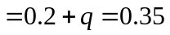 A1∫
(2)
(d) M1
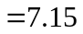 A1
(2)
(e) 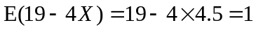 B1
(1)
(f) 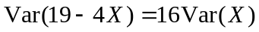 M1
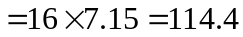 A1
(2)
Total 13 marks

Notes:

7(a) 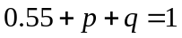 award B1. Not seen award B0.
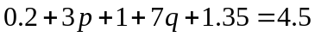 or equivalent award M1A1
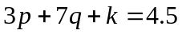award M1.

(b) Attempt to solve must involve 2 linear equations in 2 unknowns
Correct answers only for accuracy.
Correct answers with no working award 3/3

(c) Follow through accuracy mark for their q, 0<q<0.8

(d) Attempt to substitute given values only into correct formula for M1.
7.15 only for A1
7.15 seen award 2/2

(f) Accept ‘invisible brackets’ i.e. 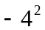 Var (X ) provided answer positive.
Anything that rounds to 114 for A1.

